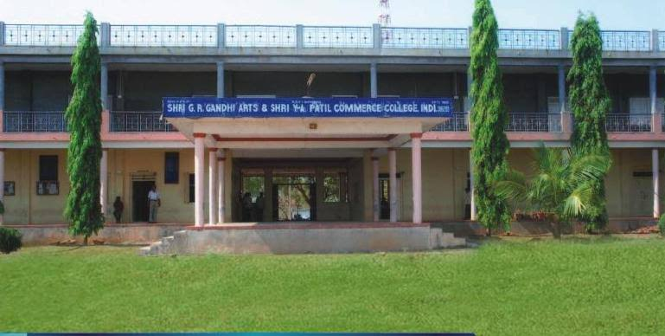
CRITERION VII - INSTITUTIONAL VALUES AND BEST PRACTICES
7.1.5 - Green campus initiatives include
1. Restricted entry of automobiles
2. Use of bicycles/ Battery-powered vehicles
3. Pedestrian-friendly pathways
4. Ban on use of plastic
5. Landscaping

INSTITUTIONAL INITIATIVES:
1. RESTRICTED ENTRY OF AUTOMOBILES: The college supports use of KSRTC buses which covering each corner of Indi to facilitate the students and staff. The institute encourages the staff and students to use public transport instead of their own vehicles for safety, security, fuel conservation and to reduce environmental pollution. The vehicles owned by faculty or students with pollution check stickers are permitted into the campus. Random checks are made to check the validation and periodicity of this certificate. For two wheelers or four wheelers, security measures are mandatory.

2. USE OF BICYCLES: Our students are staying in BCM hostel and they are using bicycle to go from hostel to college and vice versa. Students and staff members are coming from nearby villages also prefer bicycle/two willer/ public transport as a mode of transport for attending the college. It is environment friendly and prevents pollution.

3. PEDESTRIAN FRIENDLY PATHWAYS: Vehicle parking space is provided at the main entrance of the college campus. As the campus is vehicle free with some exceptions, students and staff experience comfort walking through the pedestrian friendly pathways. They are properly maintained by the campus beatification/maintenance committee.

4. BAN ON USE OF PLASTIC: Single-use plastic items such as bags, spoons, straws and cups are banned completely and awareness is created among staff and students through orientation and display boards in the premises. To restrict the use of plastic, measures have been taken to replace plastic tea cups and glasses with steel glasses in the canteen. The staff and students are informed to use steel or copper water bottles instead of plastic bottles.

5. LANDSCAPING: Landscaping of the college is worth seeing and reflects aesthetic sense. The institute has a canopy of trees and plants to make the environment pollution free to safeguard the health of all the inmates. The lawns and the trees provide shade and beautiful ambience. Utmost care is taken to develop and maintain green landscaping by trained gardeners. The construction, maintenance and beautification committee constituted in the college looks after the development and maintenance of the greenery in the campus

RESTRICTED ENTRY OF AUTOMOBILES

VEHICALS PARKING
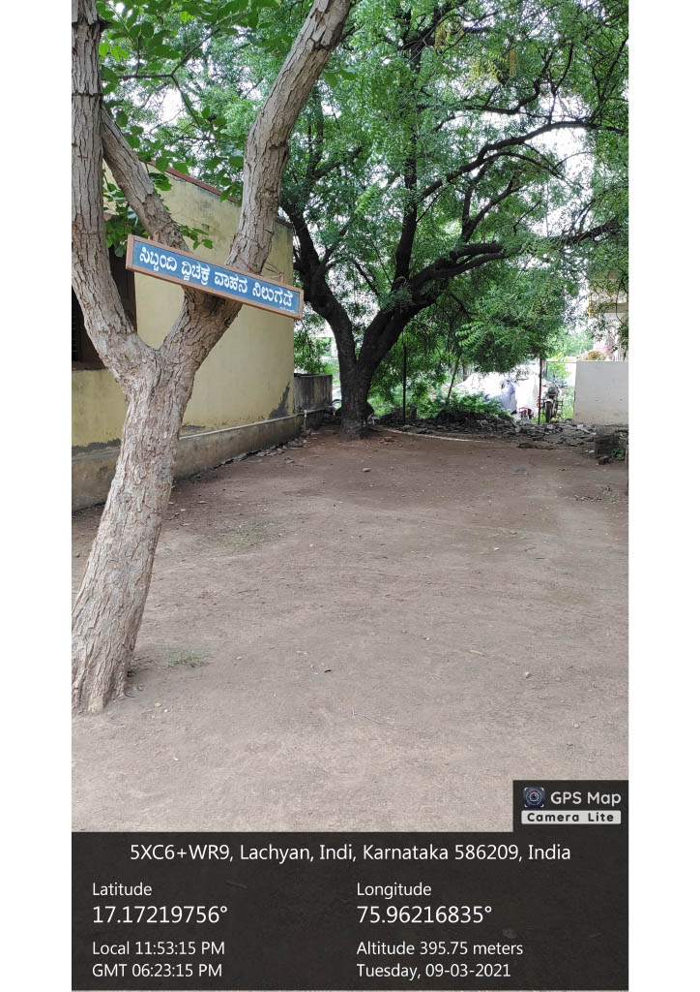
BICYCLES PARKING
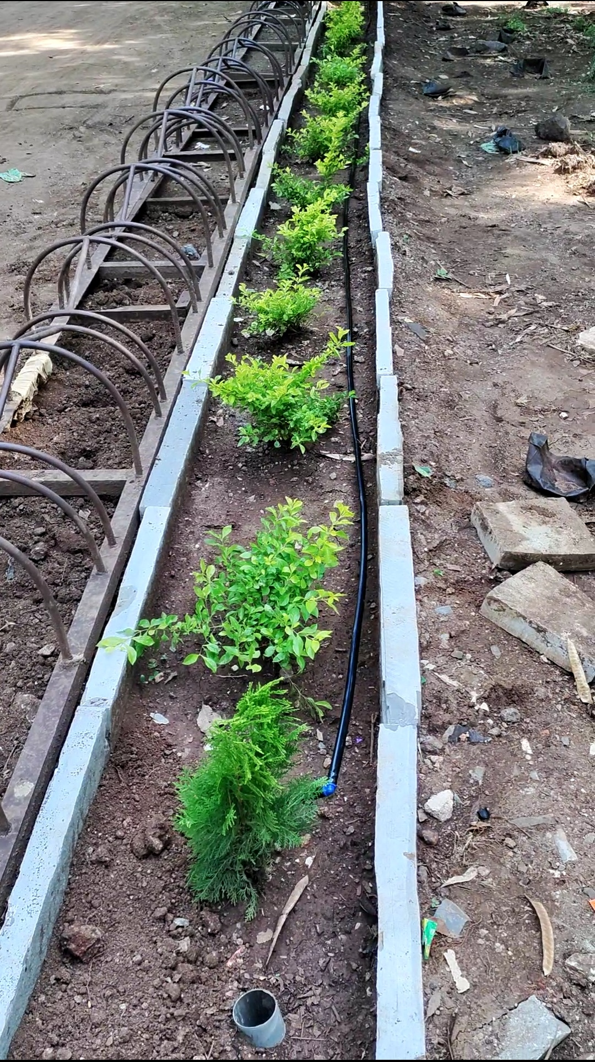
BAN ON USE OF PLASTIC

BAN ON USE OF PLASTIC
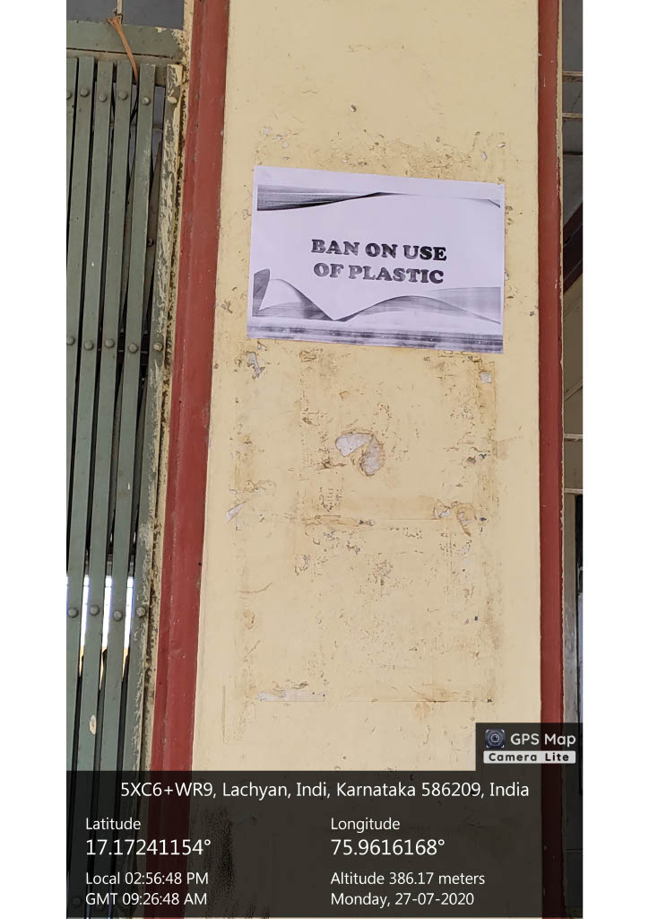

PEDESTRIAN FRIENDLY PATHWAYS
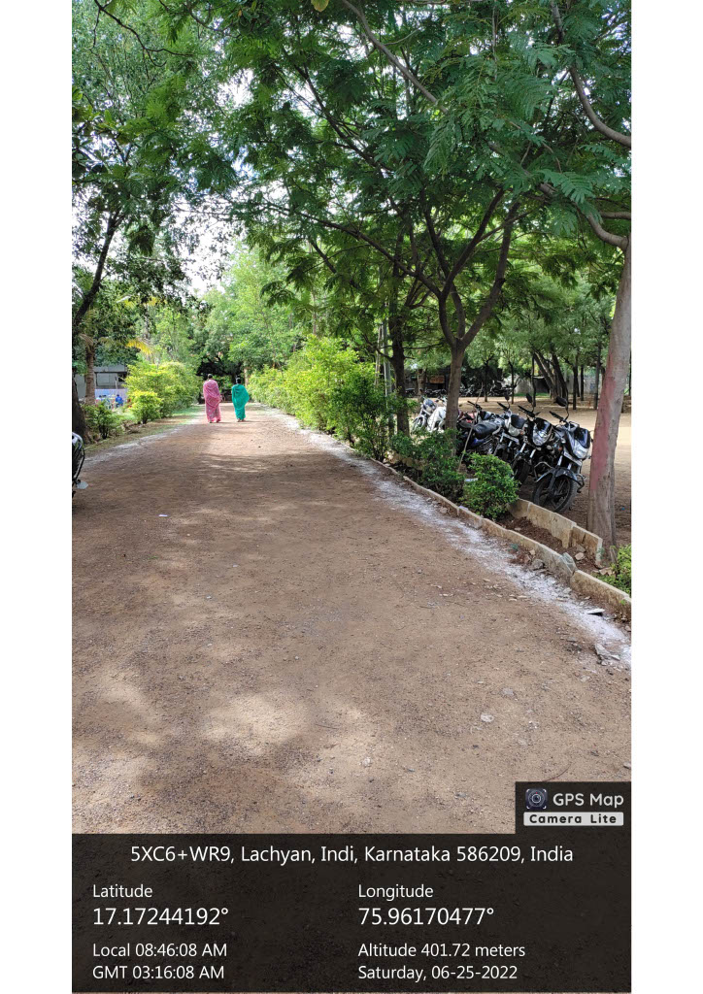

PEDESTRIAN FRIENDLY PATHWAYS 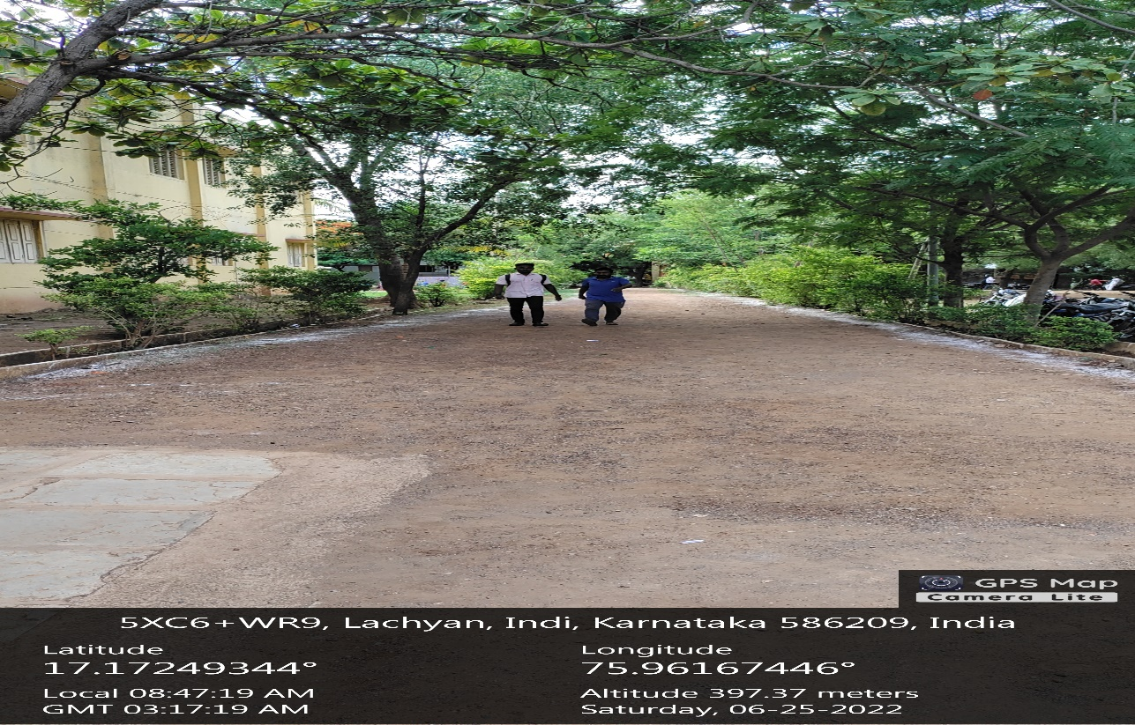

LANDSCAPING WITH TRESS AND PLANTS
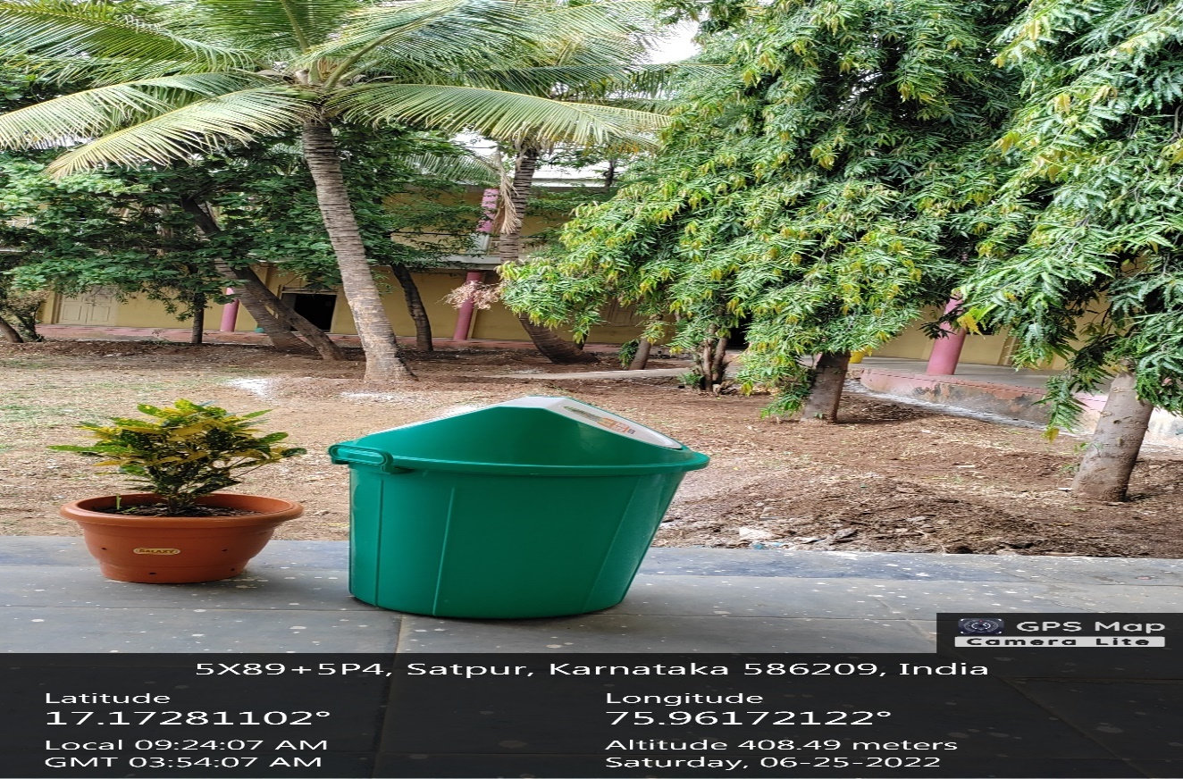
LANDSCAPING WITH TRESS AND PLANTS
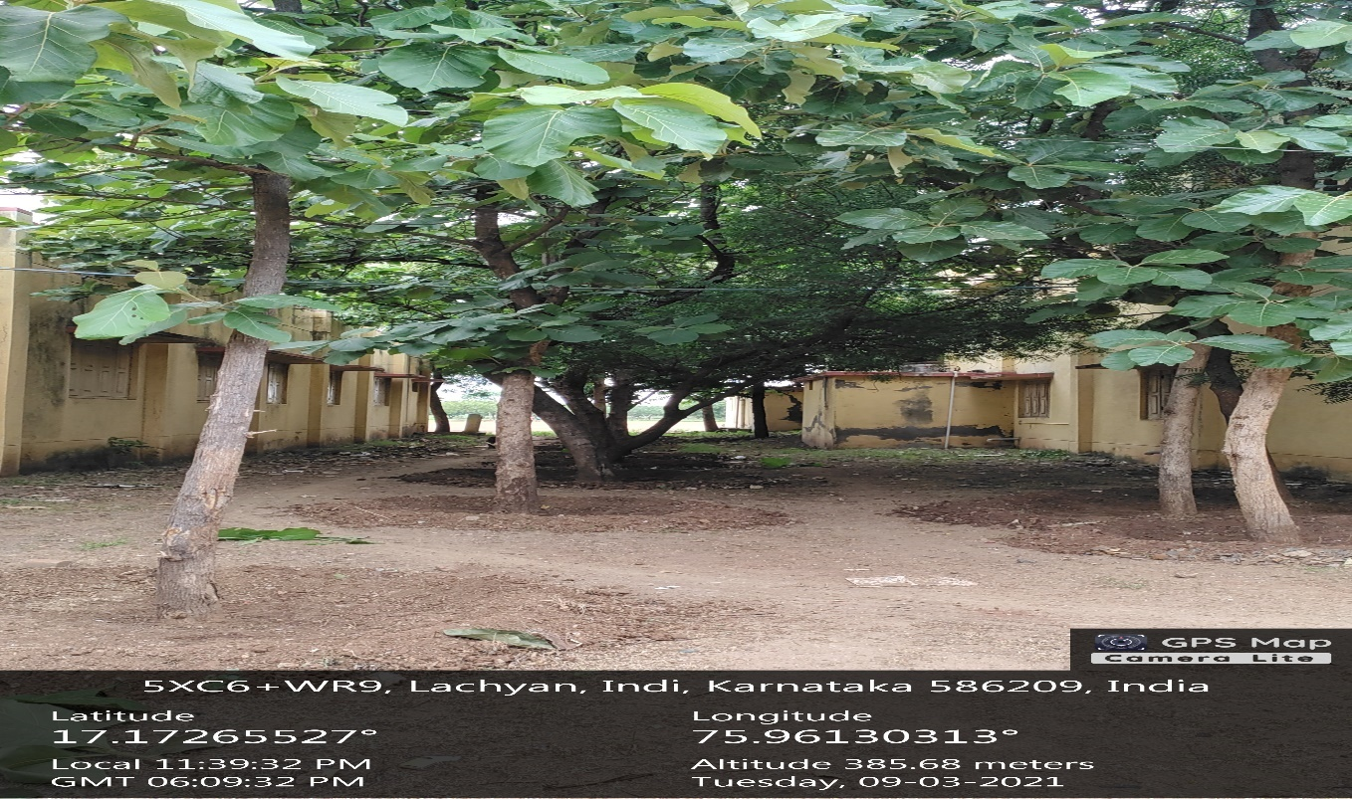

LANDSCAPING WITH TRESS AND PLANTS
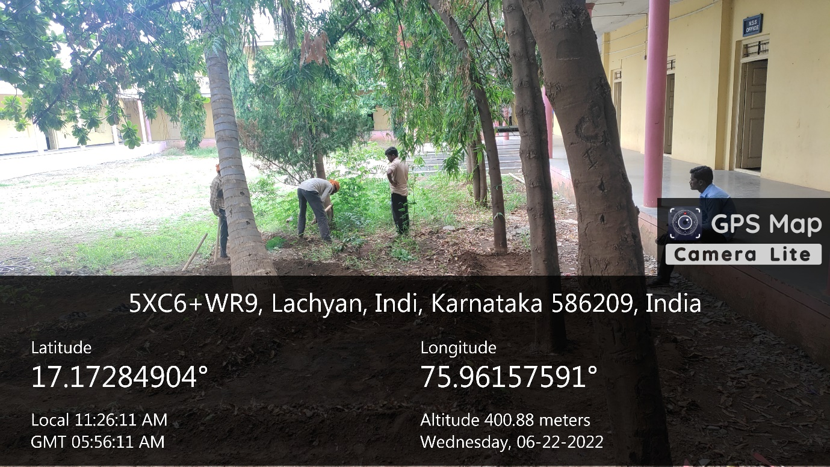
LANDSCAPING WITH TRESS AND PLANTS
